Task # 01: Write a program to display your personal information.

**SOLUTION:**

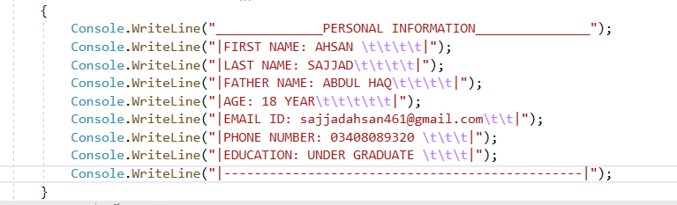

**OUTPUT:**

